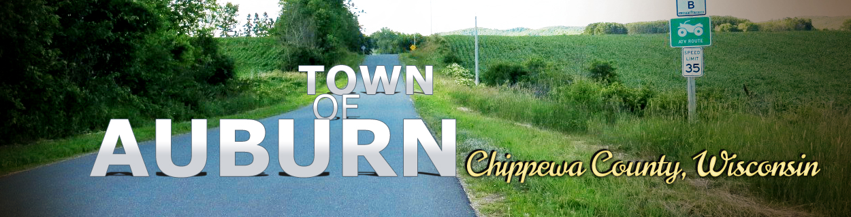

BOARD MEETING AGENDA
April 14th, 2026, at 6 P.M.
(Agenda not necessarily in this order)

- Call to Order
- Roll Call
- Review of Permits/Licenses
- Reading of Minutes
- Financial Report, Audit bills/authorize payments
- Public Comment (3 Minute Limit)
- Correspondence
- Consideration of maintenance needs and updates
- Set next meeting date and agenda
- Adjourn

